**IPT PROJECT**

**Project Description:**

Our project was to make a window service that counts the lines of code in a file or multiple files inside a folder having a common file type.

**System Architecture Diagram:**

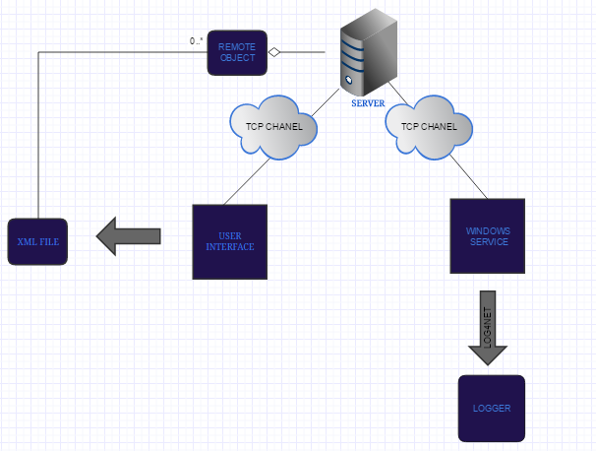

**User interface:**

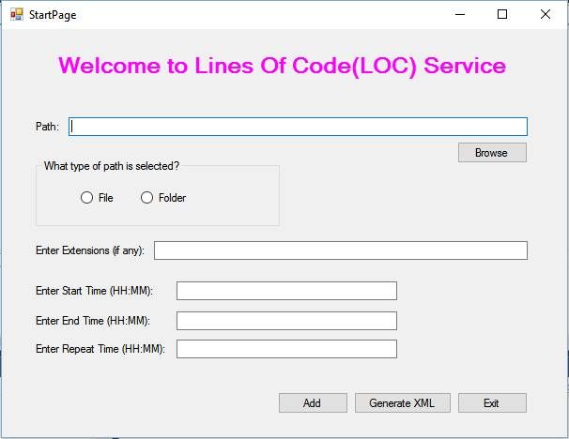

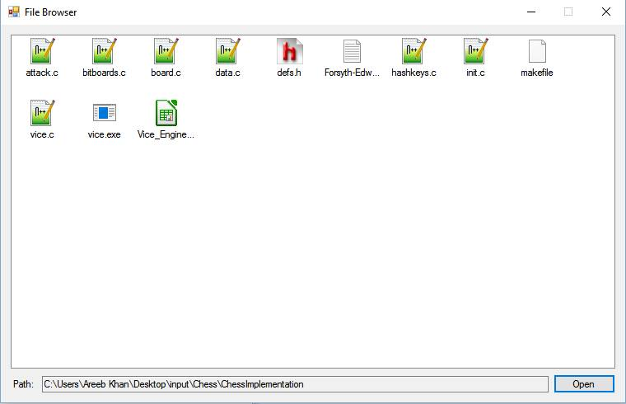

**Class Diagram:**

